**PLEASE NOTE THAT THE BEGINNING PORTION OF THIS DOCUMENT WAS REMOVED AS NOT TO REVEAL PERSONAL DETAILS ABOUT THE SOFTWARE ENGINEERING TEAM.**

**WHAT YOU ARE ABOUT TO SEE IS A “How To” Guide for an application created by our team to assist our Purchasing team with warehouse fulfillment, invoicing, EDI invoices, and creation of Purchase Orders.**

**Although Packable has closed its doors (August 22, 2022), I maintain to keep any information about the team private.**

**Thank you!**



# Table of Contents

## Part 1: Purchasing Application

### Module 1: Register and Log into the Purchasing Application

### Module 2: Purchasing Application Home Page

### Module 3: Creating Purchase Orders

### Module 4: Uploading Purchase Orders

### Module 5: Purchase Order Lookup

### Module 6: Transmissions

## Part 2: Transaction Manager

### Module 1: True Commerce Overview

### Module 2: Register and Log into the True Commerce Application

### Module 3: Transaction Manager Home Page - Options

### Module 4: True Commerce Report Menu Options

### Module 5: True Commerce Activities Menu Options

## Part 3: Summary

### Module 1: Questions, Wish List, Survey

PART 1 – Purchasing Application

Module 1: Register and Log into the Purchasing Application

Objectives:

* Registering for the new Purchasing Application
* Log into the Purchasing Application

**R**egistering for the new Pharmapacks Application created by our very own Software Development Team, is easy. The overall process allows you to use your Pharmapacks Google email and password to being the process.

Once you have registered, you will receive a confirmation email that you will have to acknowledge. After that, you will log into the Purchasing App with your Google email and password.

How To’s

**Registration:** The process to register for the Pharmapacks Application, is as follows:

1. Go to Purchasing Application:
   1. During Training, this website will be: <https://purchasing-dev.pharmapacks.net/>
   2. During Training, we can also use: <https://purchasing-staging.pharmapacks.net/>
   3. In Production, this website will be: <https://purchasing.pharmapacks.net/>

The following screenshot depicts the login screen:

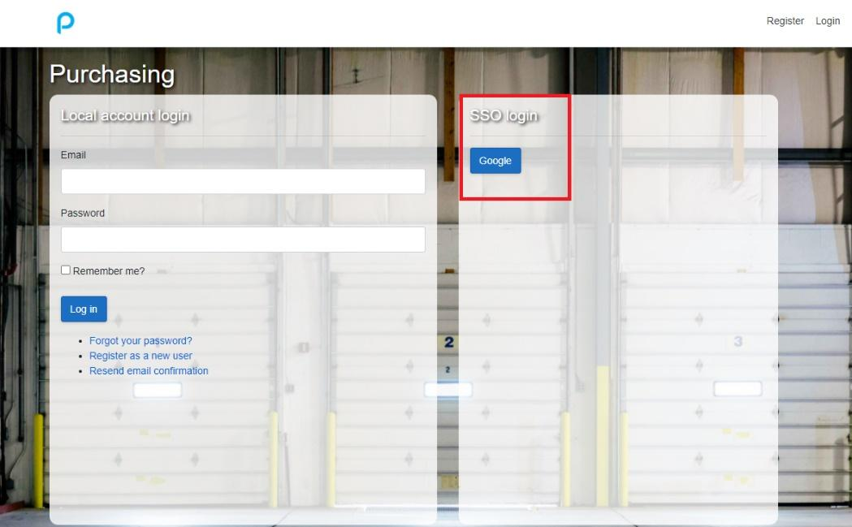

1. If this is the first time you are using the application, you will click on the Google button, and sign in with your Pharmapacks email, and password:

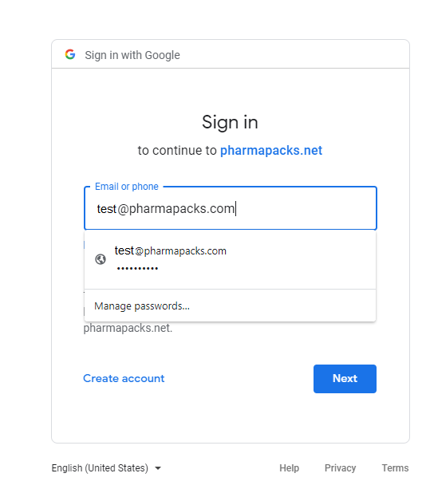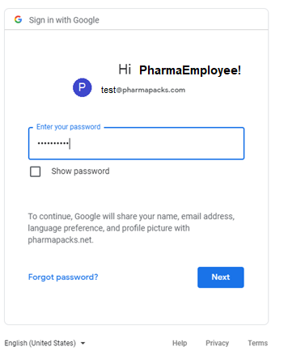

1. Next you will be asked to register to use the application:

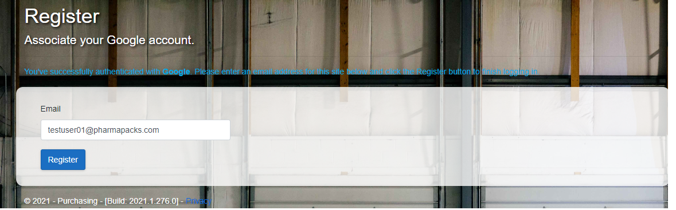

1. This will automatically send an email to your Pharmapacks Google Mail, for verification:

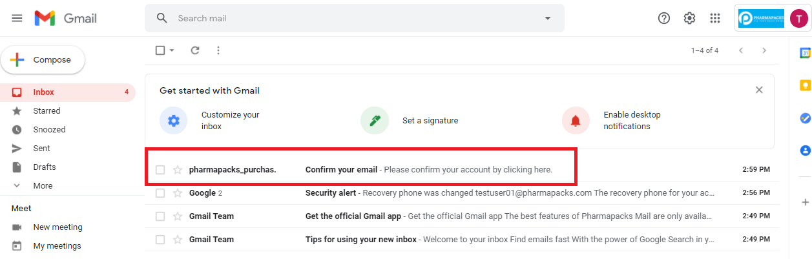

1. Open the email, and click the link to confirm:

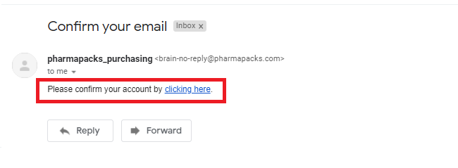

**Login:** Whether this is a first (after registration), or a subsequent login, the screenshots below will walk you through the login process

1. Once you have been successfully registered, you will need to log back into the application at :
   1. <https://purchasing-dev.pharmapacks.net/> (training)
   2. <https://purchasing-staging.pharmapacks.net/> (training)
   3. <https://purchasing.pharmapacks.net/> (production)
2. Once again, use the Google button to LOG IN:

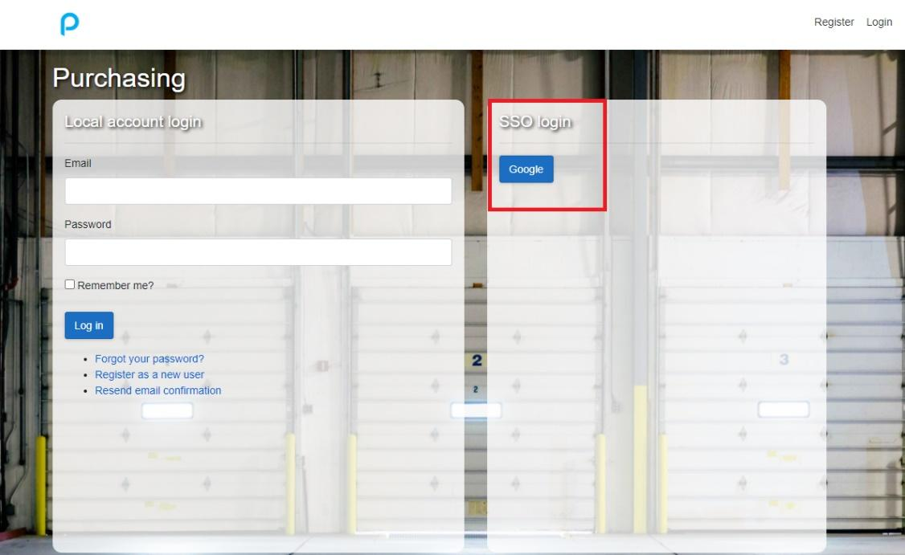

1. Fill in your login information and password:



|  |  |
| --- | --- |
|  | Register and Log Into Purchasing Application  (10 min)  What you will do:   1. Register on the Purchasing Application Website 2. Log into the Purchasing Application |

Module 2: Purchasing Application Home Page

Objectives:

* Navigate the Home Page
* Understand Available Options

**T**he Home Page of the Purchasing Application was designed for ease of use, with everything you need for success, contained in one place. This application will have various phases coming up, and as the Software Engineering team adds functionality, the application will grow for all your Purchasing needs.

Below is a screenshot of the Purchasing Application Home Page:

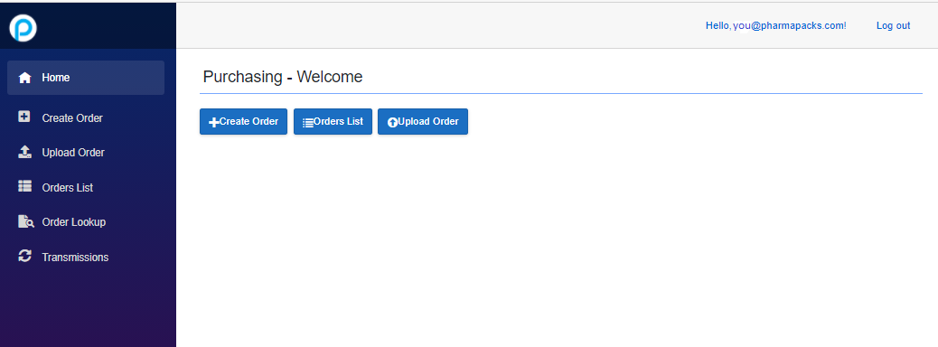

Notice that the left menu contains 6 options. See the table below for a brief overview of each:

|  |
| --- |
| **Home:** Return to this home page anytime |
| **Create Order:** Create new purchase orders, and add items to the purchase order, through bulk, or single entries. |
| **Upload Order:** Upload an order in .csv format, edit and finalize the order, or cancel the order. |
| **Orders List:** Displays a paginated list of orders, including status, PO Number, Notes, Create Date, and Transmission Status. In addition, new purchase orders can be created from this option. |
| **Order Lookup**: Can search orders by typing them in, but a recently used list is also available as a dropdown list. |
| **Transmissions:** Shows transmission status of Purchase Orders |

This course was designed specifically for you! You are about to take a journey through the new purchasing application, working with each option, and the details behind it. In addition, you will have hands on practice labs to try all the options and ask any questions you may have. We will use development servers, set up by the Software Engineering Team for this purpose.

Module 3: Creating Purchase Orders and Adding SKUs

Objectives:

* Creating Purchase Orders
* Adding SKUs
  + Bulk Load
  + Individual Load

**C**reating Purchase Orders has never been simpler. For training purposes, we will be using a development environment, but in production, you will be able to go to the Purchasing app on a Pharmapacks website, designed specifically for the Purchasing Department.

While creating Purchase Orders, you will find it effortless to add SKU’s to the order, either in bulk, or one at a time.

How To’s

**Create a purchase order:** From the Purchasing Application home screen, there are two options to create a purchase order (see screenshot below).

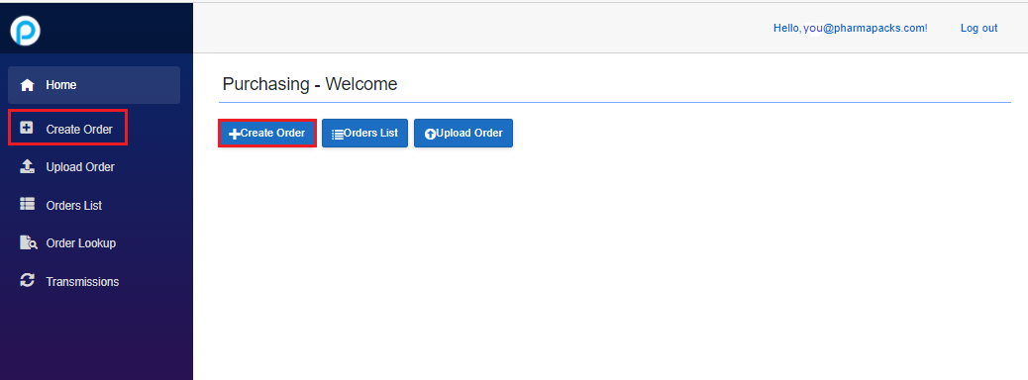

Either choice will bring you to the following screen:

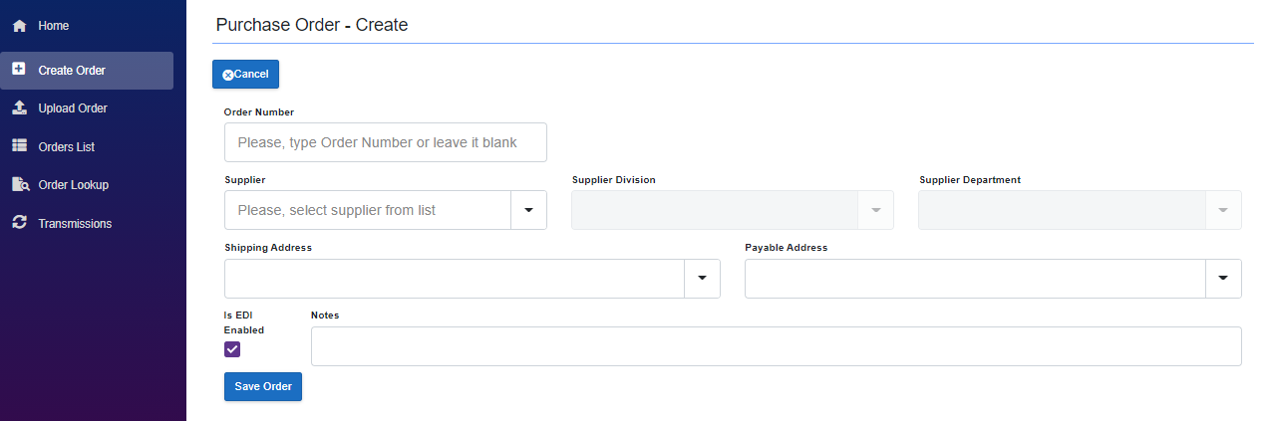

Steps to creating a new purchase order (Fields):

1. Order Number: Can be left blank, and the Purchasing App will automatically assign this number, or pre-approved orders can be manually typed in.
2. Supplier: Choose from a dropdown list of Suppliers
3. Shipping Address: Choose from a dropdown list of Shipping Addresses
4. Payable Address: Choose from a dropdown list of Payable Addresses
5. Is EDI Enabled: Check this box (or not), depending
6. Notes: Add any pertinent notes
7. Click on Save Order

Note: if the Order Number is a duplicate (because it was manually typed in), the error received in the following screenshot:

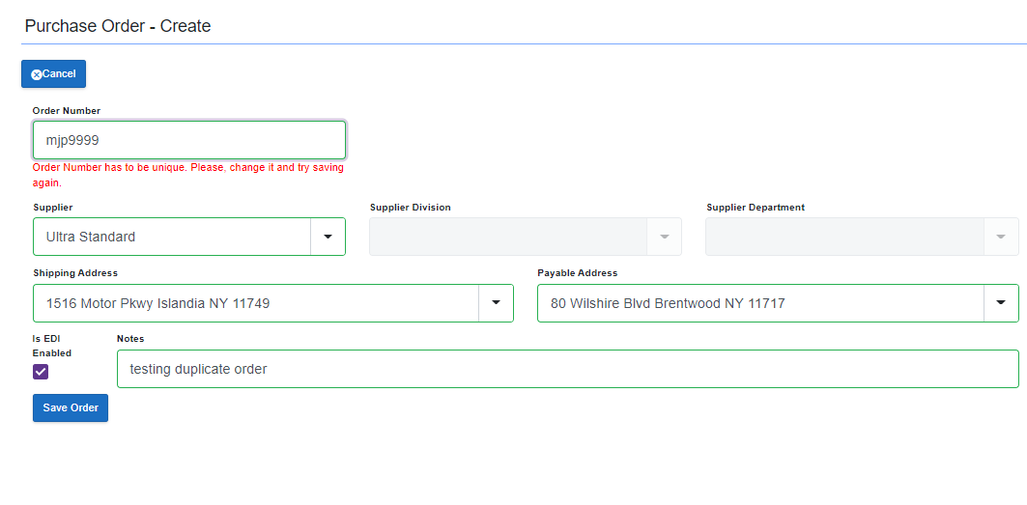

1. Once a unique Order Number has been entered (either manually or automatically), and the “Save Order” button has been clicked, the following screen will appear:

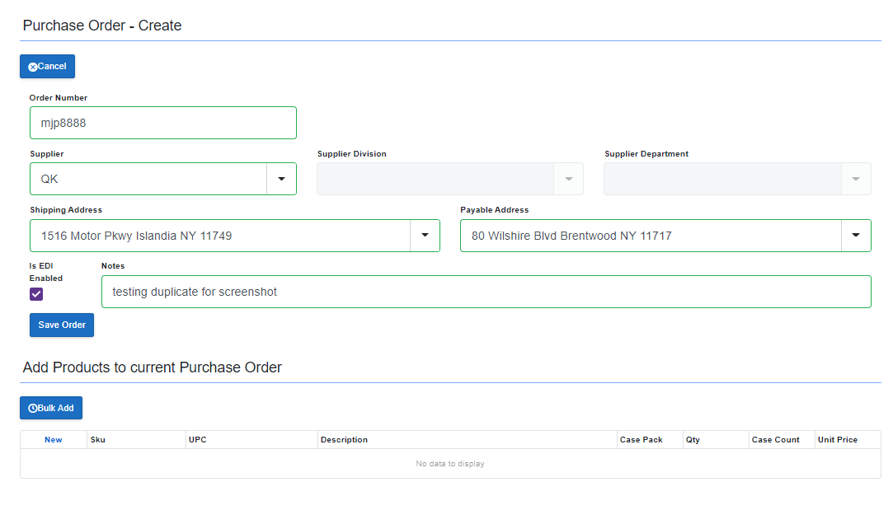

**Please Note: A purchase order entry can also be cancelled before clicking the Save Order button, by choosing the  button.**

**SKUs:** Create new, or bulk upload SKUs

New SKUs or Bulk Addition of SKUs can be added to the purchase order as follows:

**Bulk Add:** SKUs can be bulk added by clicking the  button from the bottom of the newly created purchase order.

1. Once the bulk add button has been clicked, a new screen will open, depicted in the screenshot below:

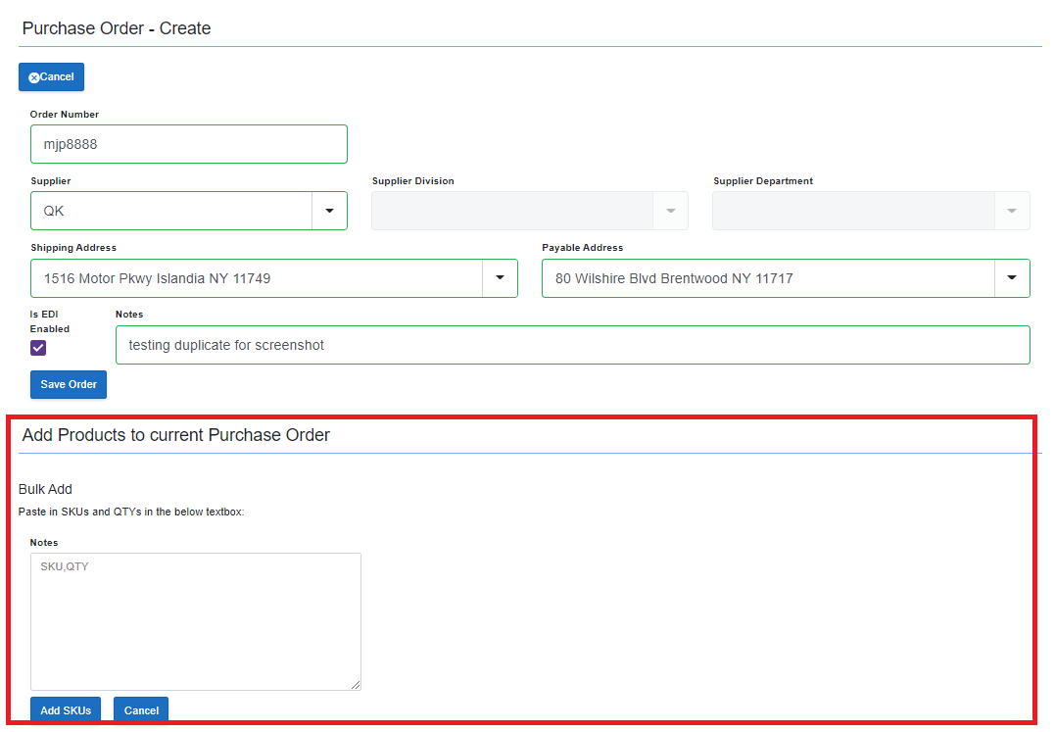

1. The screenshot shows the required format to bulk add. The rules for entering bulk add SKUs, are as follows:
   1. The format shown in the screenshot above is SKU, QTY. This is called comma delimited and the comma must appear between the SKU and QTY field(s), for the new SKUs to be submitted. These values can be manually entered, or copied and pasted in. (SKU numbers originate from the Brain application at: <http://brain.pharmapacks.com:888/>) 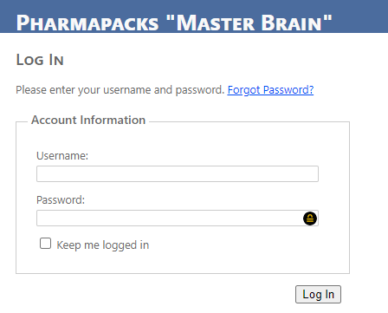
   2. SKUs must be numeric
   3. SKUs must be 7 digits
   4. SKUs must end with either a 0 or 5

**Individual SKU Add:** SKUs can also be added individually by clicking the  button, from the bottom of the newly created purchase order:

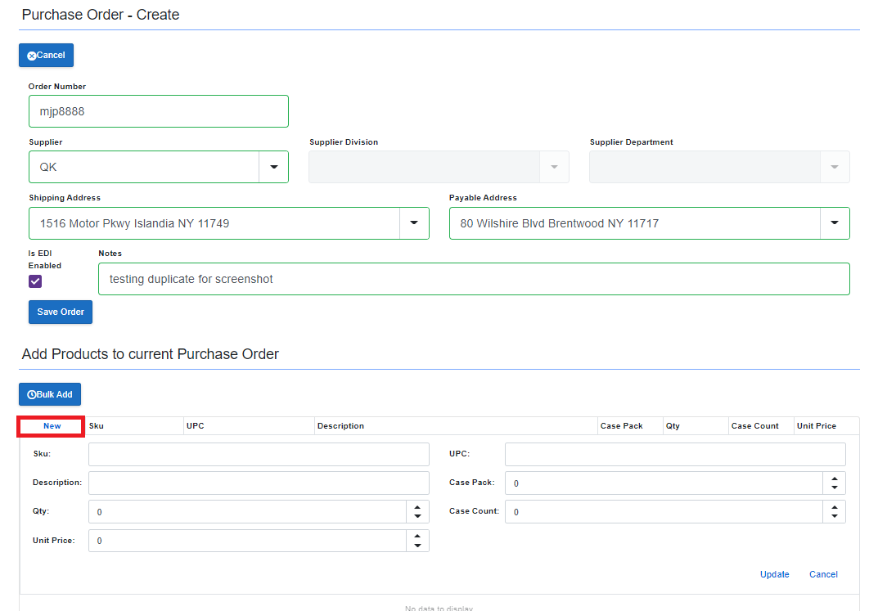

Once the new button has been clicked, a new screen will open, depicted in the screenshot below:

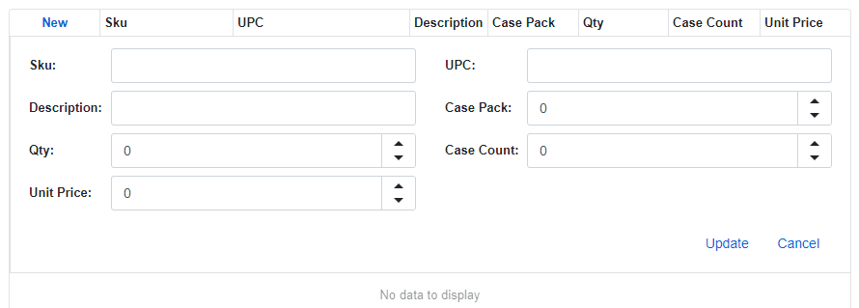

Instructions for entering SKU Data:

1. When entering data on the New SKU screen, you will need to provide a SKU number or a UPC number. If you fill out either a SKU or a UPC, the other value will auto populate.

Both of these values originate from the Brain application at:

<http://brain.pharmapacks.com:888/>

1. SKU Rules:
   * SKUs must be numeric
   * SKUs must be 7 digits
   * SKUs must end with either a 0 or 5
2. UPC Rules:
   1. UPC codes can be alpha-numeric
   2. UPC codes can be varying lengths



1. As seen in the screenshot below, the description and unit price field(s) will auto fill.
2. Case Pack, Qty, and Case Count must be filled in with numeric entries.

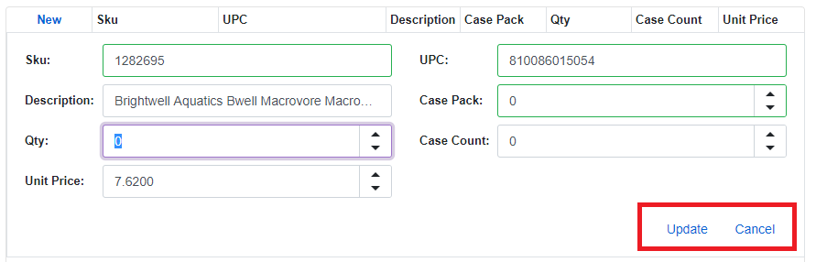

1. Once the individual SKU form is filled out, the user can choose either Update (to submit the new SKU), or Cancel to return to the Purchase Order Screen:

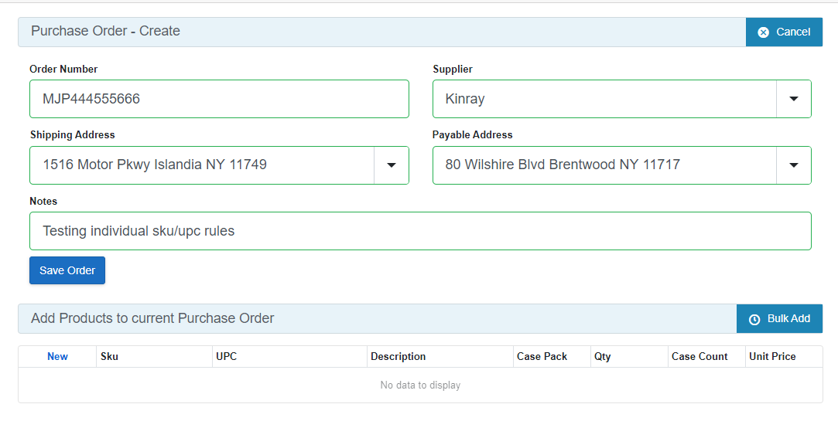

|  |  |
| --- | --- |
|  | Create a new Purchase Order and SKUs  (15 min)  What you will do:   1. Create a new Purchase Order (and cancel) 2. Use the bulk load option to add SKUs to previously created Purchase Order 3. Use the individual Add SKU functionality 4. Learn to cancel any new SKU activity (bulk or individual add) 5. Submit the new Purchase Order |

Module 4: Uploading Purchase Orders

Objectives:

* Uploading existing Purchase Orders
* Edit existing Purchase Orders
* Finalizing and Locking
* Submitting the Purchase Order

**N**ow that the new Purchasing Application is in place, note that in the future, the need to upload Purchase Orders, will happen automatically.

However, currently, you may need to manually upload Purchase Orders. And, in the new application, there is a process which will help you do this in a very speedy manner.

How To’s

**Upload a purchase order:** From the Purchasing application home screen, Chose the option “Upload Order” (see below):

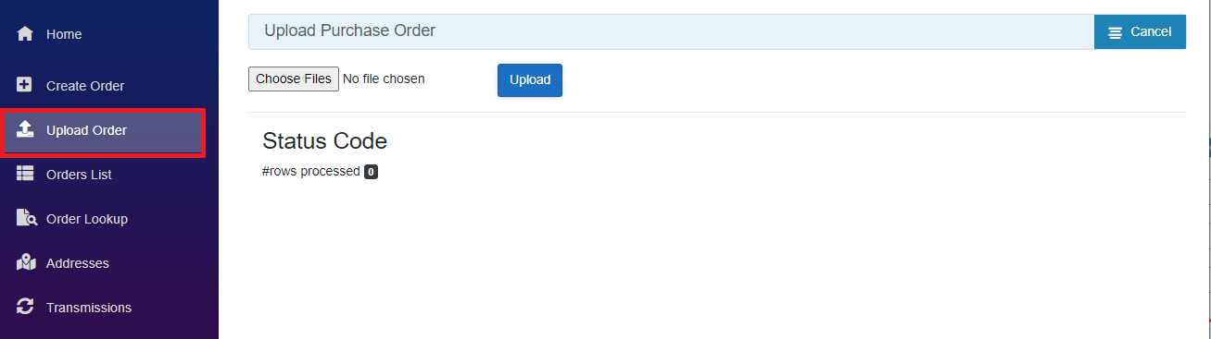

Next, follow the steps below to choose and upload a file:

1. Click on the button
2. Navigate to the desired PO. This file will likely be a .csv file but saved as excel. For the upcoming Lab/Practice, training files will be provided.
3. Click on the PO, then choose “Open”

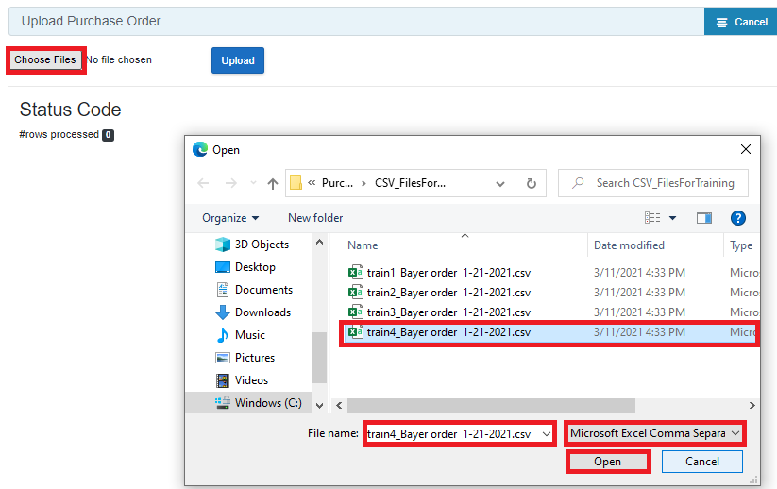

1. See the following screen:

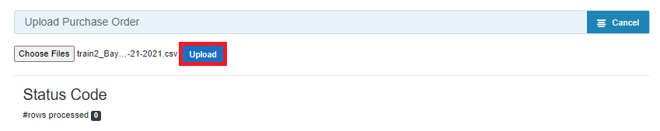

1. Click the button
2. The following screen will appear:

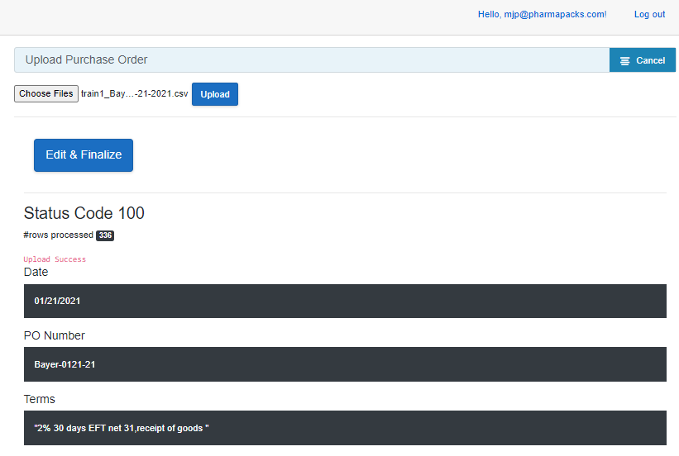

1. Click the button
2. See the following screen:

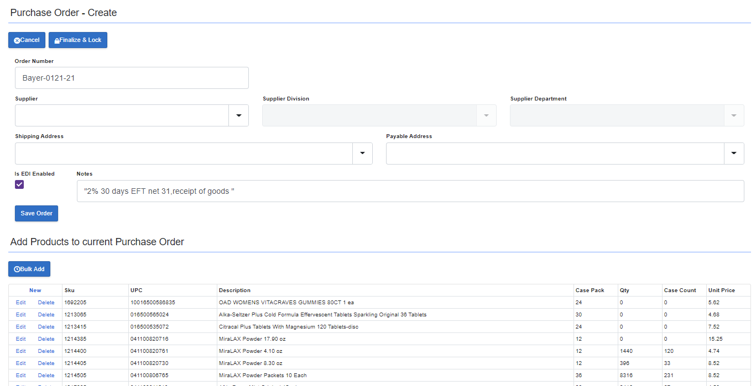

Now, you have an opportunity to change this order in any way (name, Supplier, Addresses, Notes, etc.), as well as having the ability to add new products either through Bulk, or Individual Add. See screenshot below:

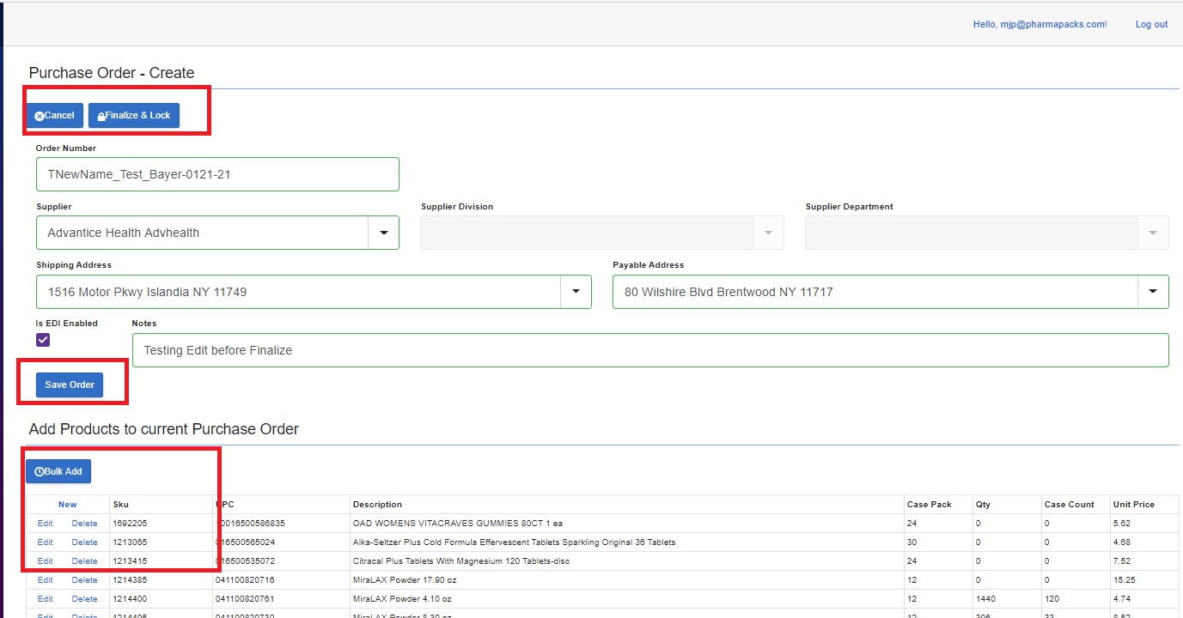

Lastly, the Finalize and Lock button is clicked to submit the order.

Once the Finalize and Lock button is clicked, the following screen will appear:

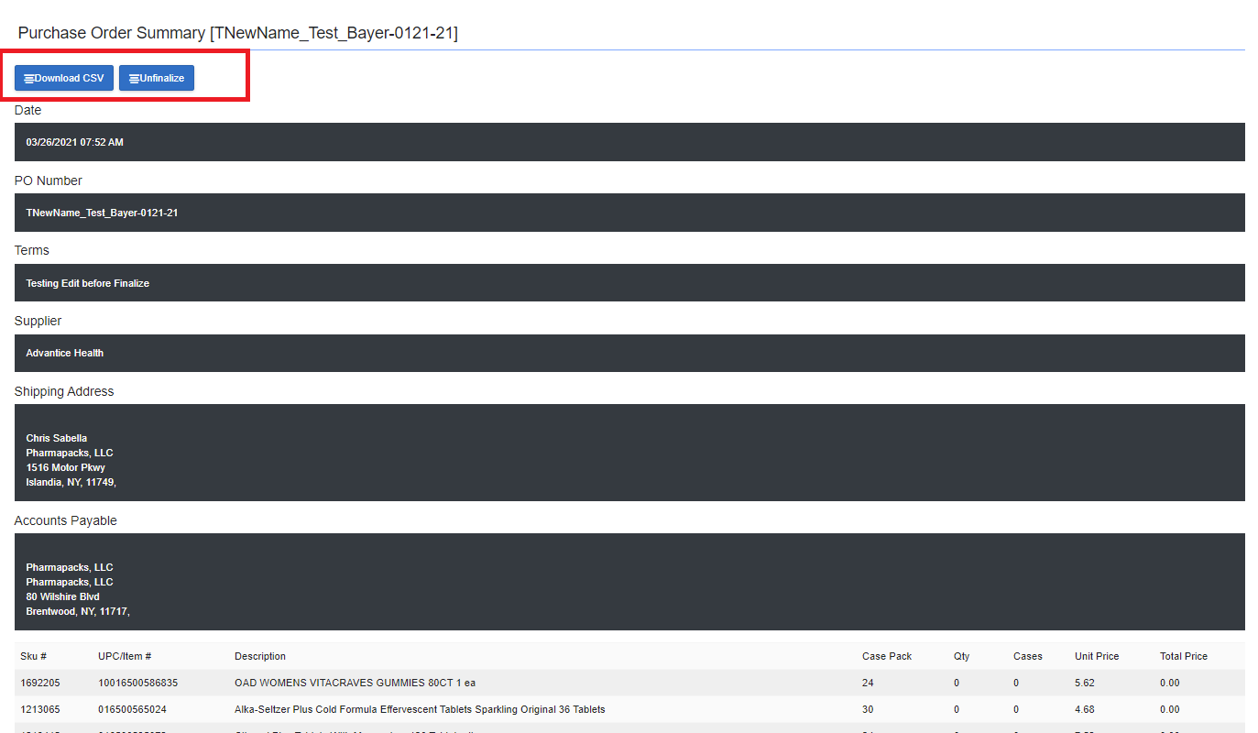

NOTE TO MJ: Add finalize inst here – in future only orders that haven’t been finalized in tc can be unfinalized.. if they are need to edit and get new PO number….

This is a summary of your order, and it allows you to unfinalized (stop the transmission), or download the .csv file. If using Excel, the .csv file can open in Excel and will look like this:

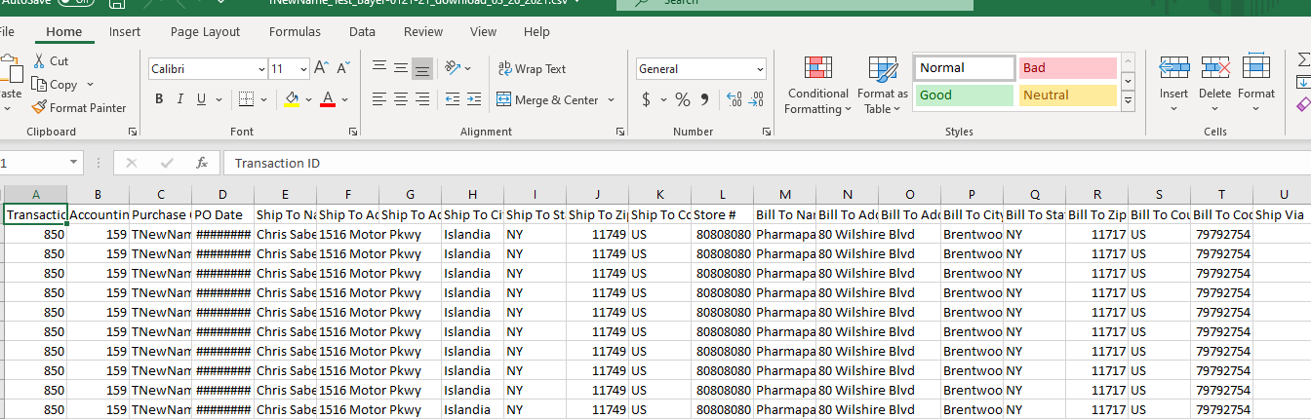

Notice that the transmission ID is 850 for each line item.

|  |  |
| --- | --- |
|  | Upload an existing Purchase Order, Edit Purchase Order, Finalize Purchase Order  (10 min)  What you will do:   1. Browse for an existing Purchase Order. 2. Edit the Purchase Order. 3. Lock and Finalize the Purchase Order. 4. Un-finalizing the Purchase Order. |

Module 5: Purchase Order Lookup

Objectives:

* Manually Enter Purchase Order
* Use the Most Recent Purchase Order
* Show the Purchase Order

**L**ooking up Purchase Orders is a straight-forward process, which will allow you to view purchase orders in record time.

How To’s

**Order Lookup:** The process to look up an order, is as follows:

1. From the left menu, choose Order Lookup

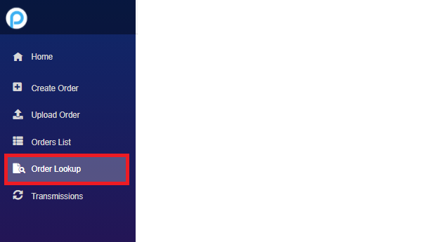

You will see this screen:

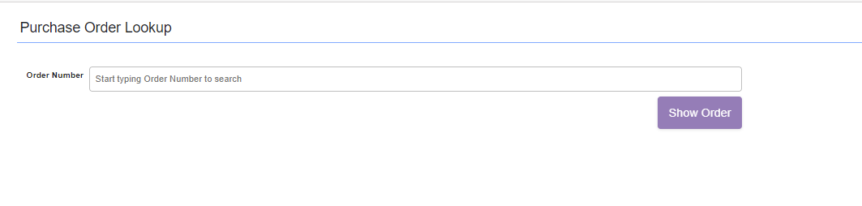

1. Either use the dropdown to see most recent orders, or manually enter the Purchase Order number.

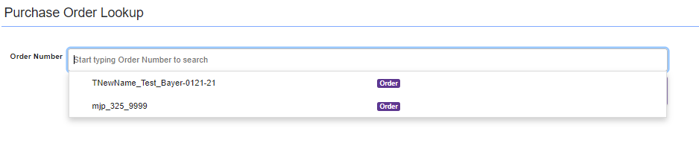

1. If using the most recent option, simply click the desired Purchase Order.
2. Finally, click the button to see the requested Purchase Order.

Please note: as of 3/26/2021, there are pieces of the Show Order process which are:

MJ NOTE: this is fixed

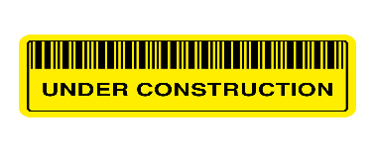

This Photo by Unknown Author is licensed under CC BY-SA

|  |  |
| --- | --- |
|  | Lookup a Purchase Order  (5 min)  What you will do:   1. Manually type in a Purchase Order to lookup. 2. Use the Most Recent Purchase Orders to lookup. 3. Click the Show Order button.   This Photo by Unknown Author is licensed under CC BY-SA |

Module 6: Transmissions

Objectives:

* Understand the Transmissions Menu Option

**T**he Transmissions menu is a fantastic addition to this software, because it allows you to see the status of the transmission, and whether it has been transmitted to True Commerce. In addition, it shows the area of the Transaction Manager in True Commerce that it will reside in (example: Outbox).

How To’s

**Transmissions:** The process to view Transmissions is as follows:

1. From the left menu, choose Transmissions:

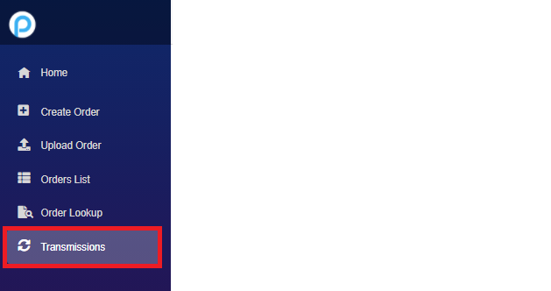

1. The following screen will appear: (the screen image has been cut in two, for the purposes of being able to see the entire option). The left half of the screen will show the Id, Status, Scheduled Time, and when it was sent.

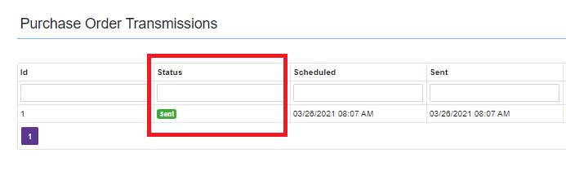

The second half of the screen is depicted below:

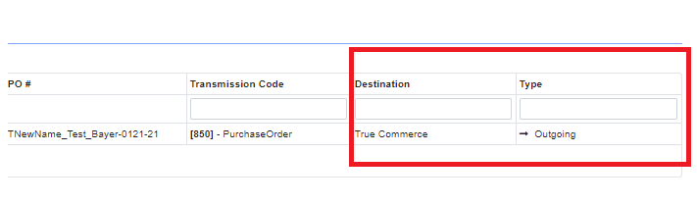

The screen is chock full of great information. Please see below for the available options:

* Status: Sent, Received, Processing, Failed, Canceled (with more possible options in the future)
* Destination: True Commerce, etc.
* Type: Outgoing, etc.

|  |  |
| --- | --- |
|  | Transmission Viewing  (3 min)  What you will do:   1. Click on the Transmission Option 2. View the status of the items |

PART 2 – TRUE COMMERCE/TRANSACTION MANAGER

Module 1: True Commerce

Objectives:

* Overview - True Commerce
* Logging into True Commerce
* Overview the Home Page
* Overview of Transaction Manager (the area which will be most used by the Purchasing Team)
  + Transaction Manager
    - Outbox
    - Inbox
    - Sent
    - Deleted
    - Search

Overview - True Commerce

**T**rue Commerce is a company which has created a website/application to view and manage transmissions and processes for:

* Purchase Orders
* Trading Partners
* Website Activity
* Reporting

True Commerce has a feature called Transaction Manager. The Transaction Manager feature will be the main option that Pharmapacks Purchasing Team will be using. When Purchase Orders are transmitted by the new Purchasing Application, they are transmitted to True Commerce, and can be viewed in Transaction Manager. From this point, Suppliers can get the Purchase Orders, for the purpose of fulfilling them. However, the Purchase Orders are by default, in .csv format. Transaction Manager will be processing those orders and transforming them into an EDI format (Electronic Data Interchange). The EDI format is what many of the Trading Partners/Suppliers will need to process orders.

NOTE: to MJ- Purchase orders for non-edi should also be entered into PO application for purposes of tracking.

**Note: Not all Suppliers will use EDI. This is the purpose of the “EDI Enabled” button, that we learned about in the Purchase Order Application Training. Please see below screenshot as a reminder:

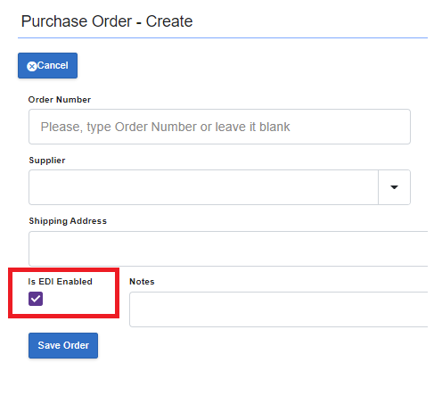

Next, we will cover the “How To’s” of how to navigate the True Commerce website, and the Transaction Manager Features:

Module 2: Registering/Logging into True Commerce

How To’s

**Logging into True Commerce:** The process to log into True Commerce is as follows:

Each person on the Purchasing Team, already has an account set up in True Commerce. If you have not logged onto the site yet, you will need to register. The process to register is outlined below:

1. Go to: [www.truecommerce.com](http://www.truecommerce.com)

See the following screen:

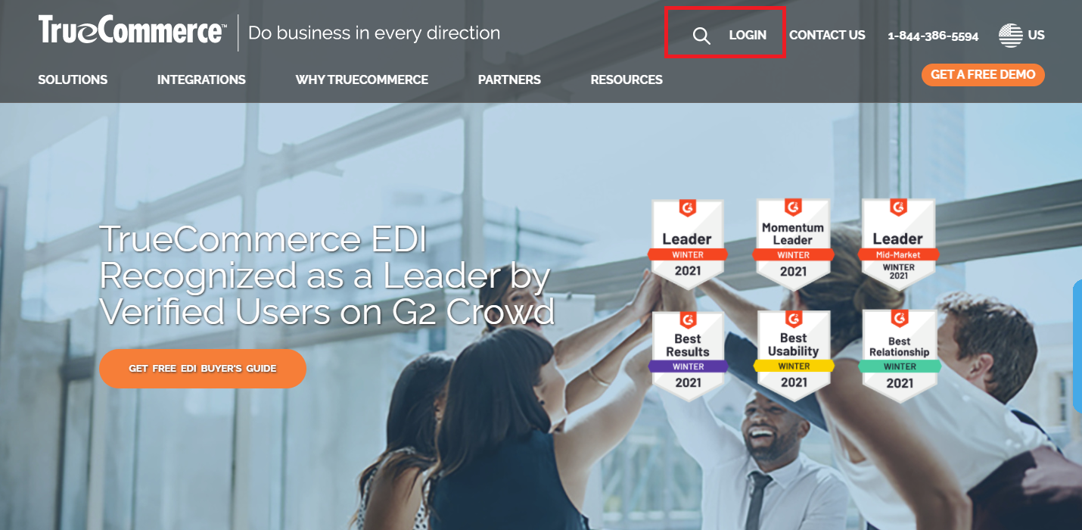

1. Click the LOGIN button. You will be using your Pharmapacks email, and Pharma123! as a temporary password for initial login

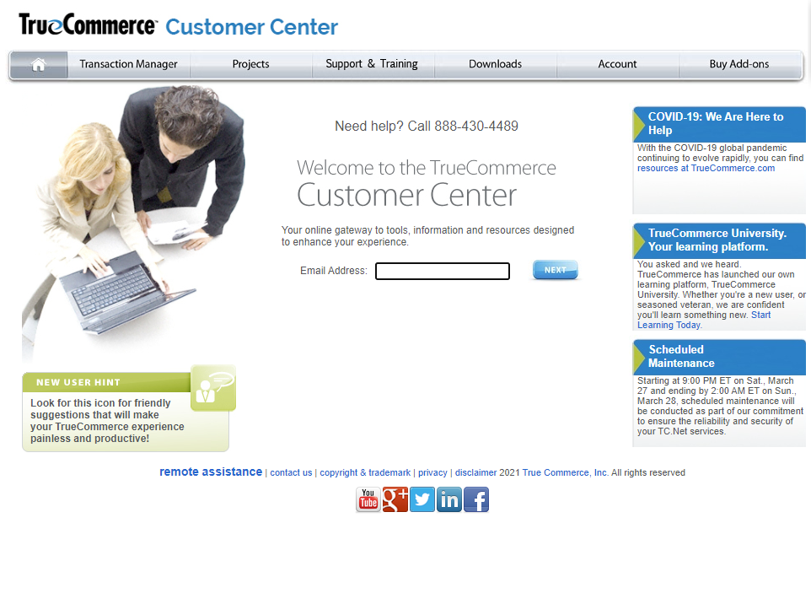

True Commerce will follow up with a validate email. Once you receive and click on the validate link, you will return to the True Commerce website. Here you will login and be asked for a password change. At this point, you can change your password to allow future logins:

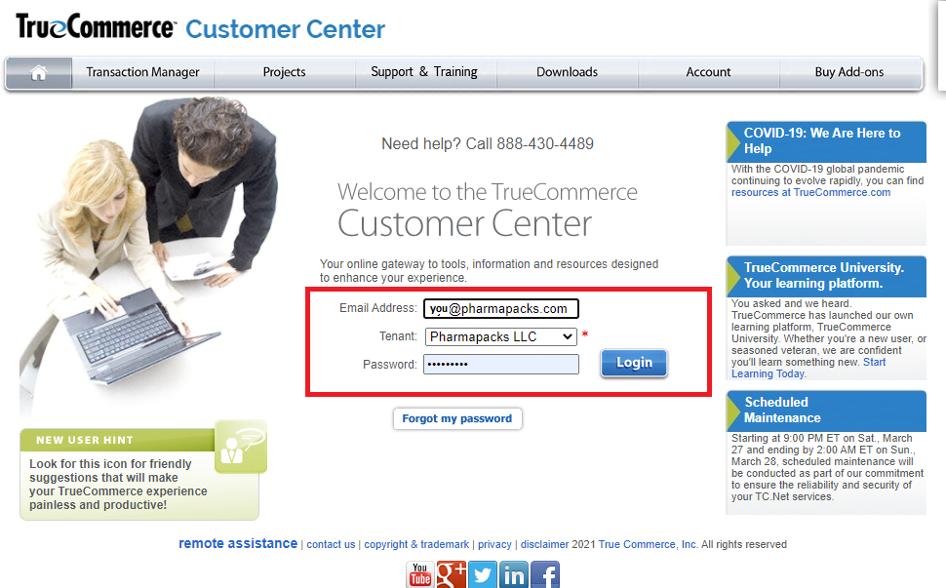

|  |  |
| --- | --- |
|  | Register and Log Into True Commerce, Navigate the Home Page  (5-10 min)  What you will do:   1. Click on the Transmission Option 2. View the status of the items |

Module 3: Transaction Manager Home Page

How To’s

**Overview the Home Page:** The process to register for the Pharmapacks Application, is as follows:

Once you are logged into True Commerce, you will see the Home Page, and the chevron in the left hub which is used to navigate the page.



After clicking this, you will see that Transaction Manager is the only option on the page, besides Search (covered later)

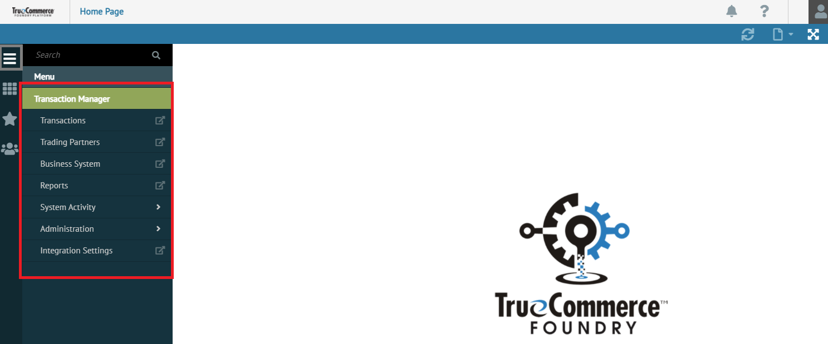

**Transaction Manager Inbox:** The Inbox in Transaction Manager will be used by the Trading Partners to send “us” responses (such as acknowledge, about to ship, or even an invoice) – will not automatically go to receive. In the future, there will be automated processes for exports. Eventually they will go into received box. For now, nothing needs to done now…

Manual – Invoices – open and send to accounting – future automation

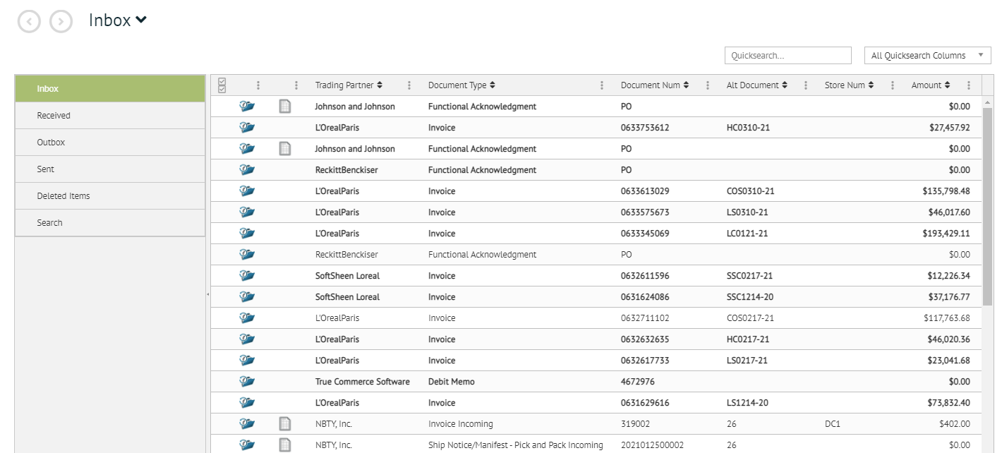

**Transaction Manager Outbox:** The Outbox in Transaction Manager will be used by the Purchasing Team, for the purpose of viewing the Purchase Orders that were sent from the Pharmapacks Purchasing Application.

NOTE to MJ – they will need to manually process but in future it will be automated

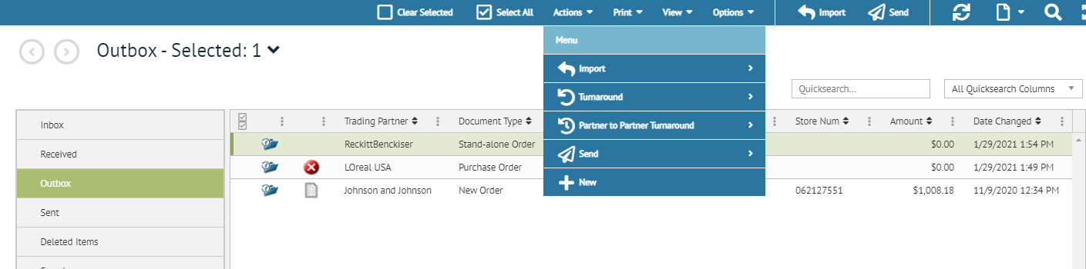

**Transaction Manager Sent box:** Transactions will appear here, after they have been sent to the Supplier (see screenshot below):

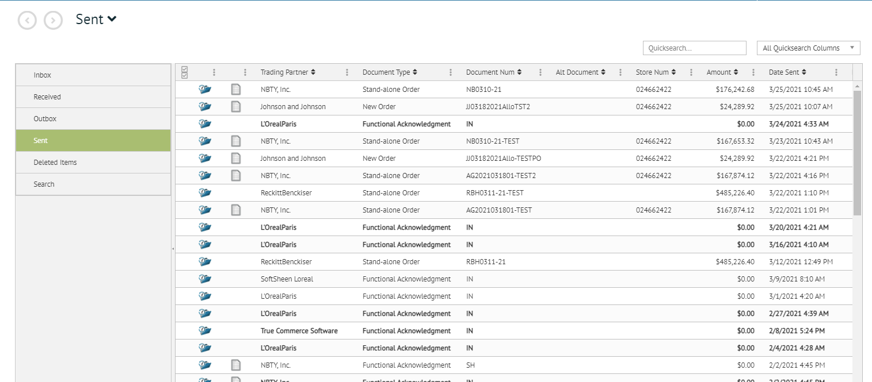

**Transaction Manager Deleted Box:** The deleted items box will show any Purchase Orders that have been deleted manually (see screenshot below):

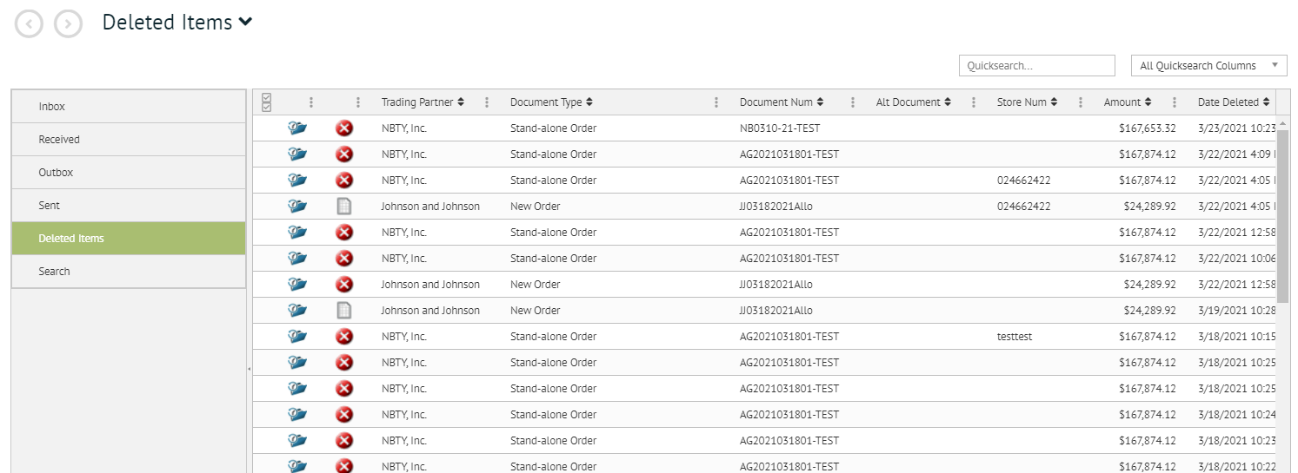

**Transaction Manager Search Box:** The Searching mechanism in True Commerce allows for various ways to search for Purchase Orders, in various stages. The screenshot below depicts the various options for Purchase Order Searching:

|  |  |
| --- | --- |
|  |  |

|  |  |
| --- | --- |
|  | Navigate through Transaction Manager Options  (5-10 min)  What you will do:   1. Click on Transaction Manger 2. Navigate through the options (inbox, outbox, sent box, deleted box, search box) |

Module 4: True Commerce Report Menu Options

**Transaction Manager Reports Menu:** The Reports Menu in Transaction Manger offers three types of Reports:

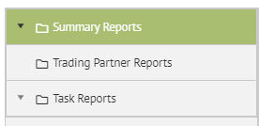

Under the Summary and Task Reports, there are more options to view:

Summary Reports:

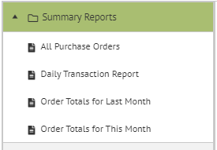

Task Reports:

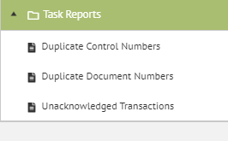

The Trading Partner Report holds various options to choose from, on one screen:

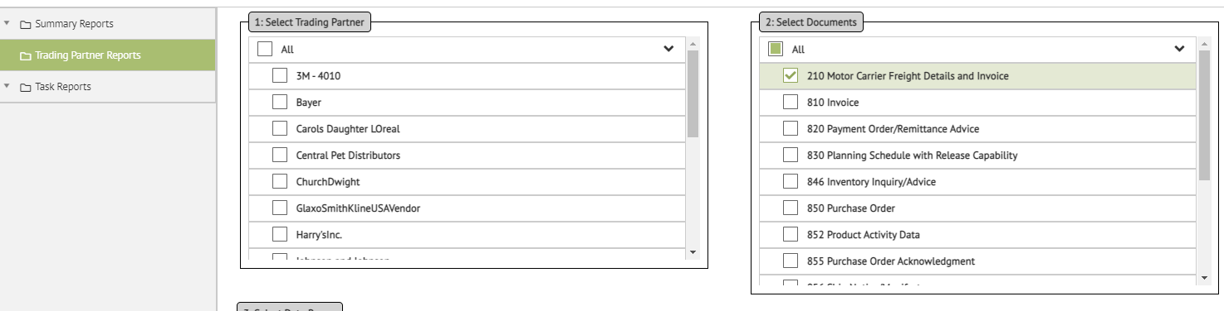

When using the Trading Partner Reports, after you choose the various options, you must click the Create Report Button (top right of screen):

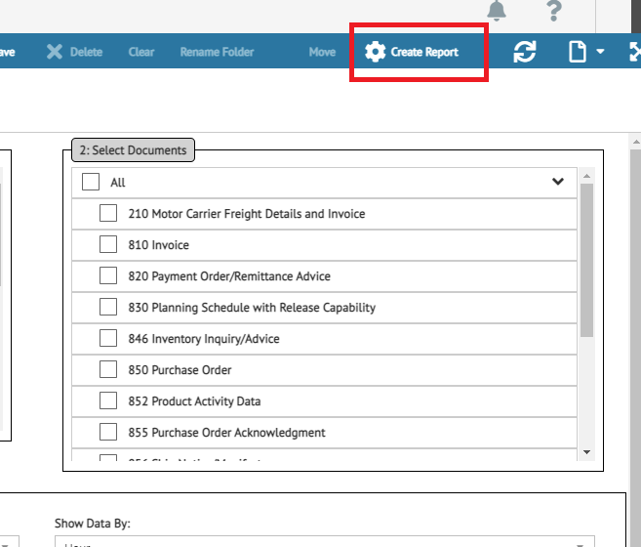

|  |  |
| --- | --- |
|  | Navigate through Report Options  (5-10 min)  What you will do:   1. Click on Transaction Manger 2. Navigate through the options (inbox, outbox, sent box, deleted box, search box) |

Module 5: True Commerce Activity Menu Options

**Transaction Manager Activities Menu:** There are various system activities which you can view if desired. All the Activities are found under the Transaction Manager menu item, under the System Activity menu.

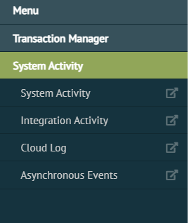

**System Activity Menu:** Shows Date, User, and Activity by Point in Time

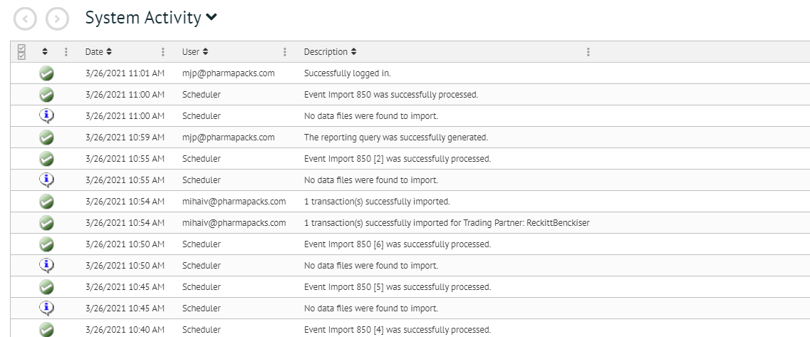

**Integration Activity Menu:** Is a wonderful overview of all Purchase Order Integration activity, including the type (example: Ship Notice), Date, Purchase Order Number, and Description.

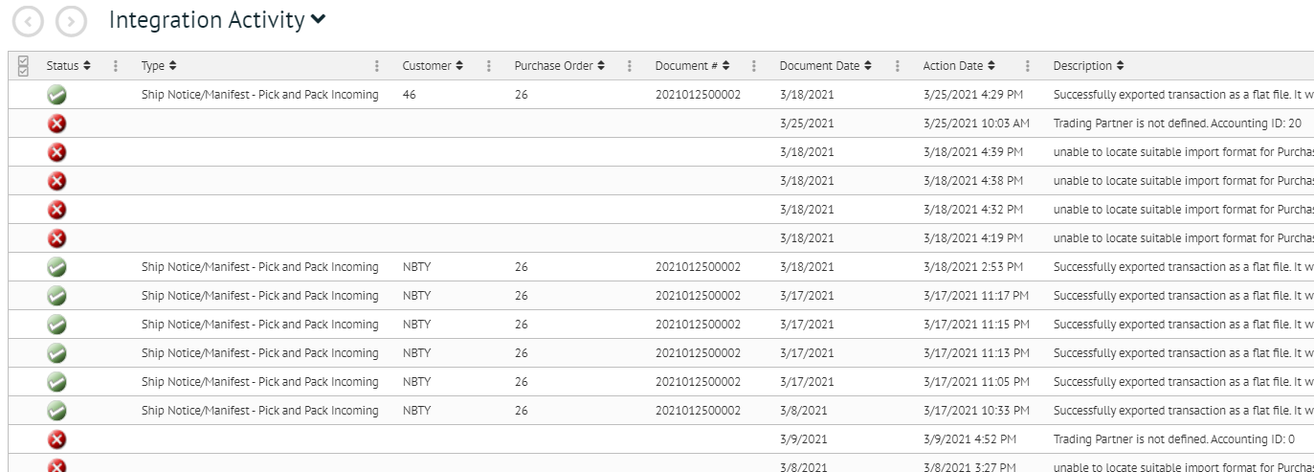

**Cloud Log Menu:** This menu is only used by True Commerce Customers who are “Cloud Customers”

**Asynchronous Events Menu:** This menu option provides the status of the Purchase Order, and tells whether the event was automated through the scheduler, or if a user manually sent a Purchase Order.

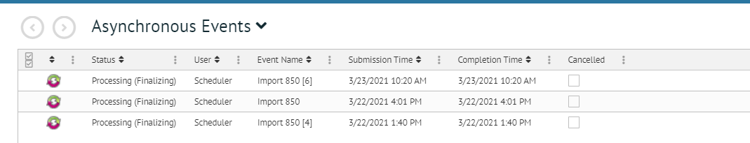

|  |  |
| --- | --- |
|  | Navigate through Activities Options  (5-10 min)  What you will do:   1. Click on Transaction Manger 2. Navigate through the options (inbox, outbox, sent box, deleted box, search box) |

PART 3 – Summary

Module 1: Questions, Wish List, Survey

QUESTIONS

Although we know that training happens quickly, and questions may not surface immediately, feel free to contact MJ via email with anything that comes up [mjp@pharmapacks.com](mailto:mjp@pharmapacks.com)

If I cannot answer the question, I will go to the Dev Team and find those answers out for you!

WISH LIST

Based on what you saw here in Training, do you have any wishes for the future of the Purchasing Application? Again, if you think of any after training, please feel free to email MJ and your wishes will be passed onto the Dev Team.

SURVEY

We would love to hear how you liked training. Please feel free to voice that now, but also, we will be sending an extremely short survey to your Gmail. It would be great if you could fill that out!

Thank you so much for taking time out of your busy schedule to join us in this milestone!